- Project = MYNTRA
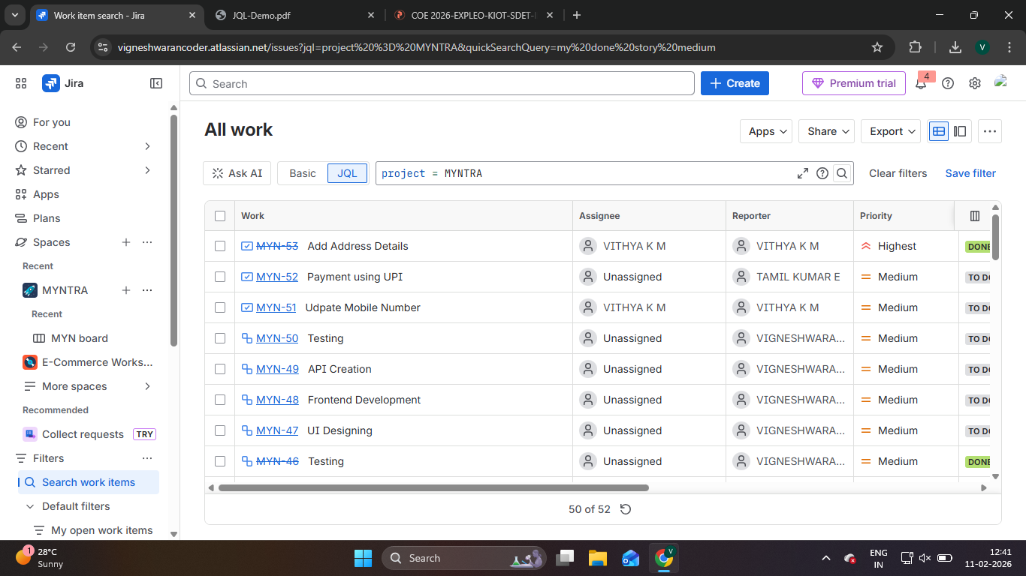

- status = DONE AND assignee = currentUser()
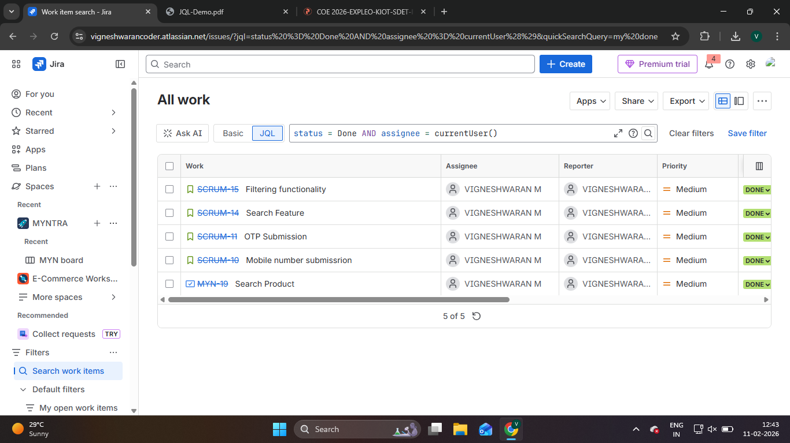

- issueType = Story
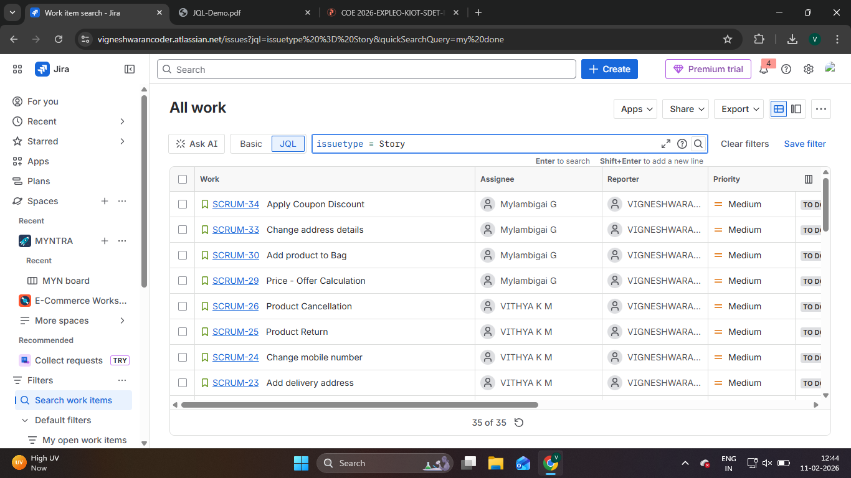

- issueType = Epic
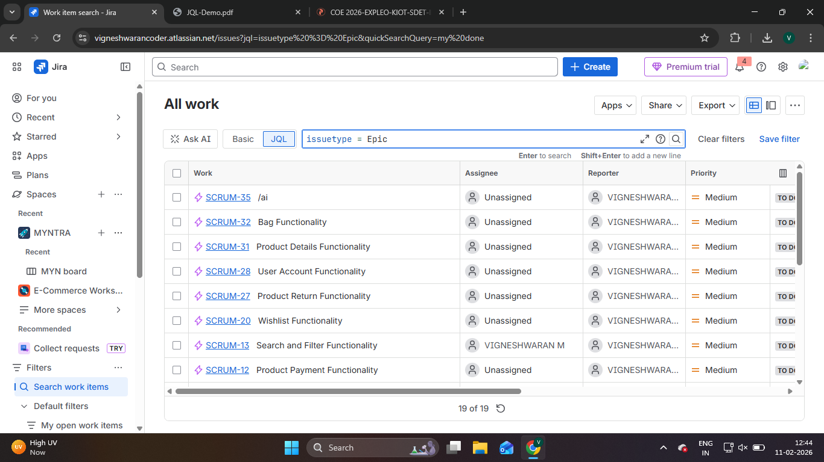

- issueType = Story and Status = “In Progress”
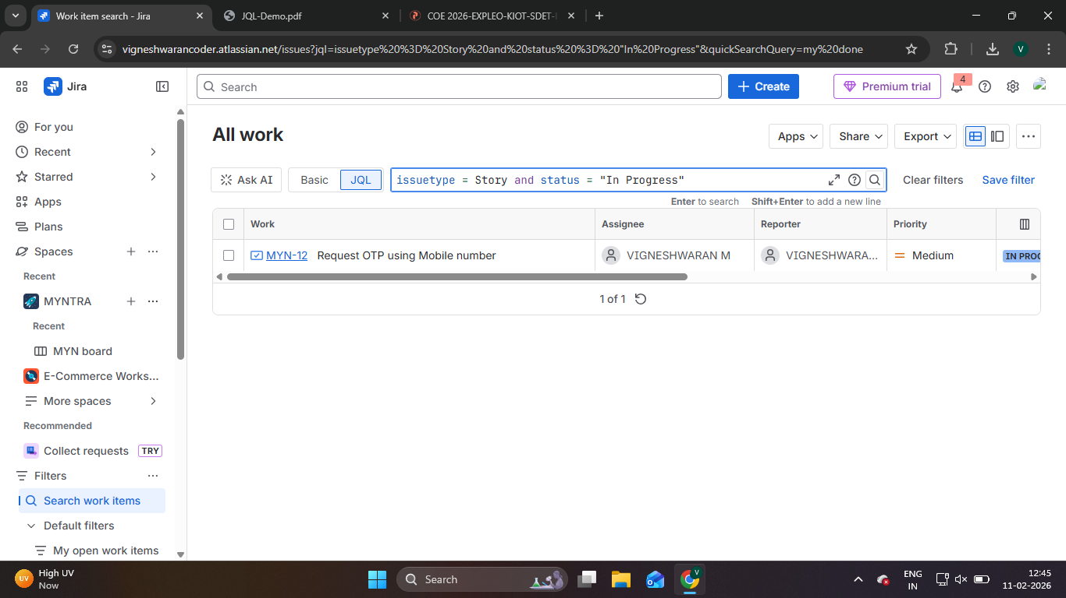

- issuetype IN (Story, Bug, Task)
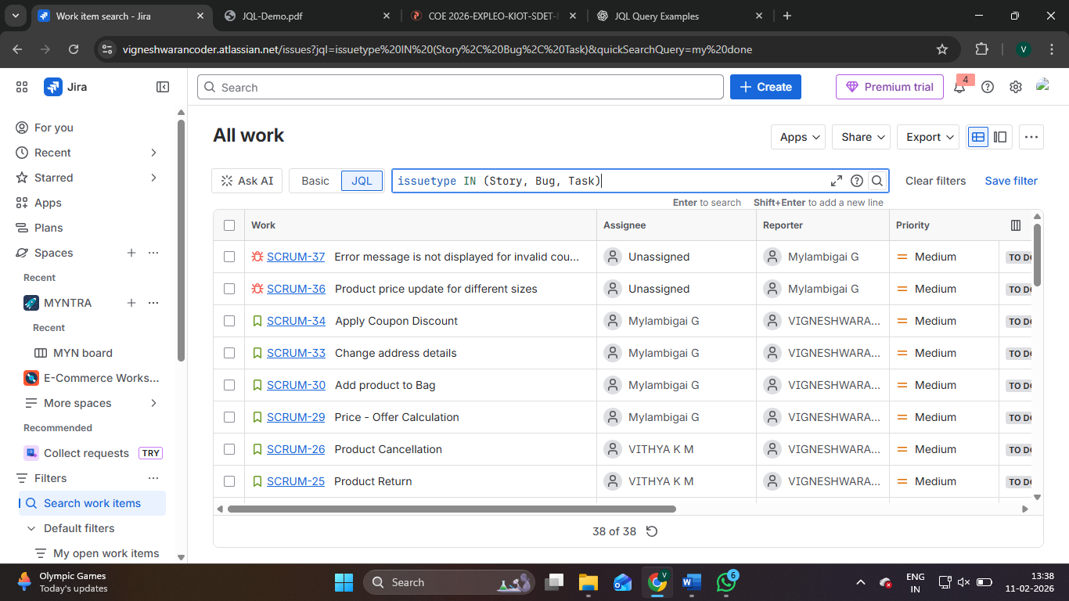

- issuetype = Bug
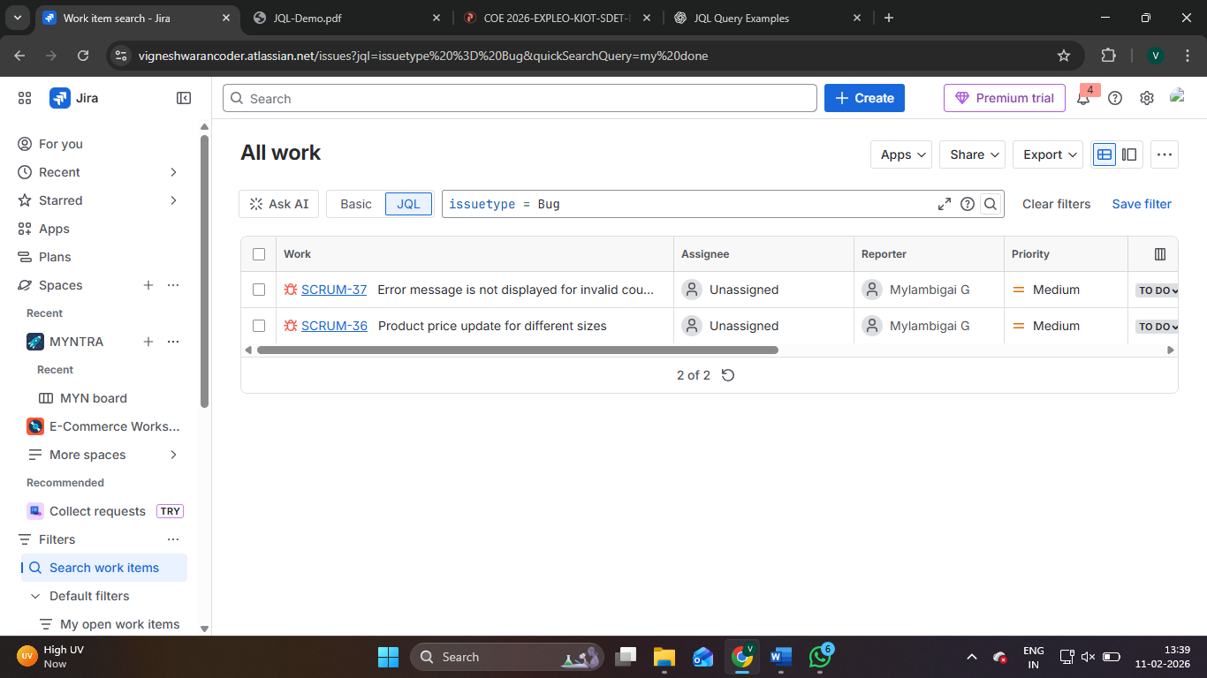

- reporter = currentUser()
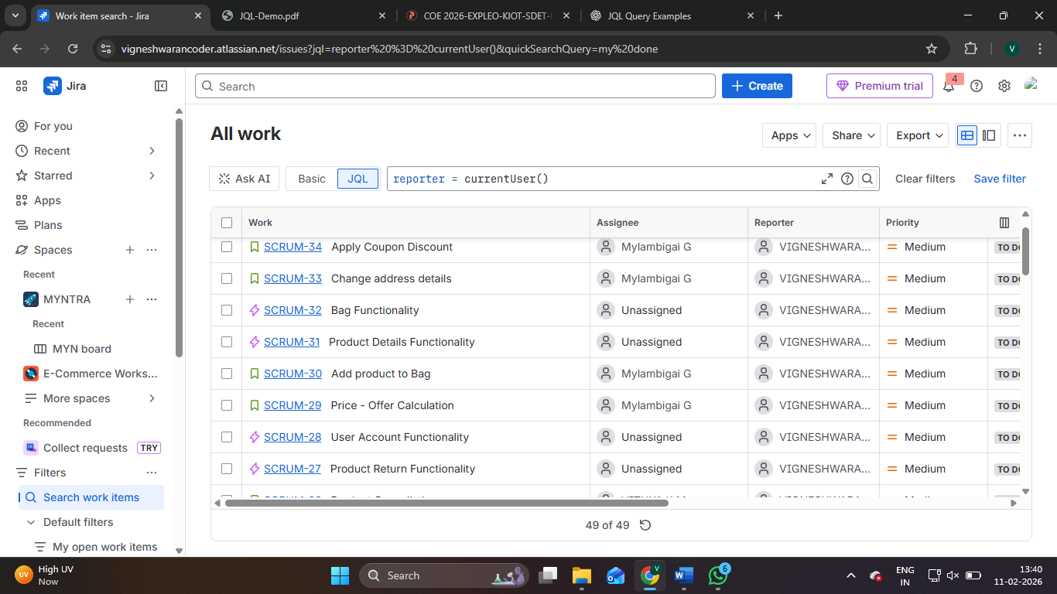

- priority NOT IN (Low, Lowest)
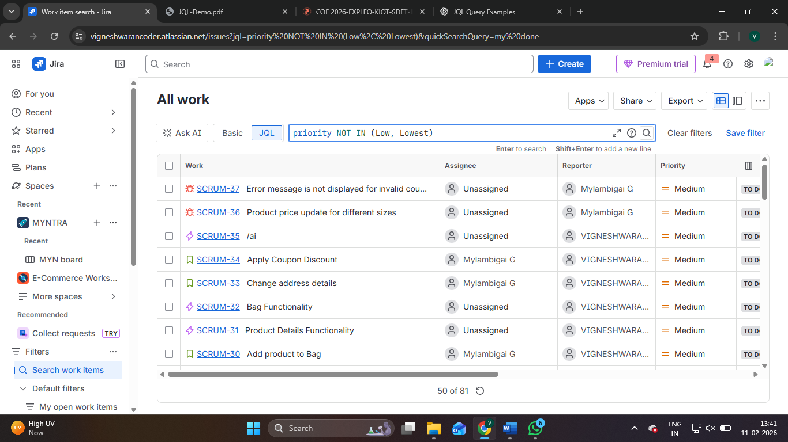

- updated >= startOfDay()
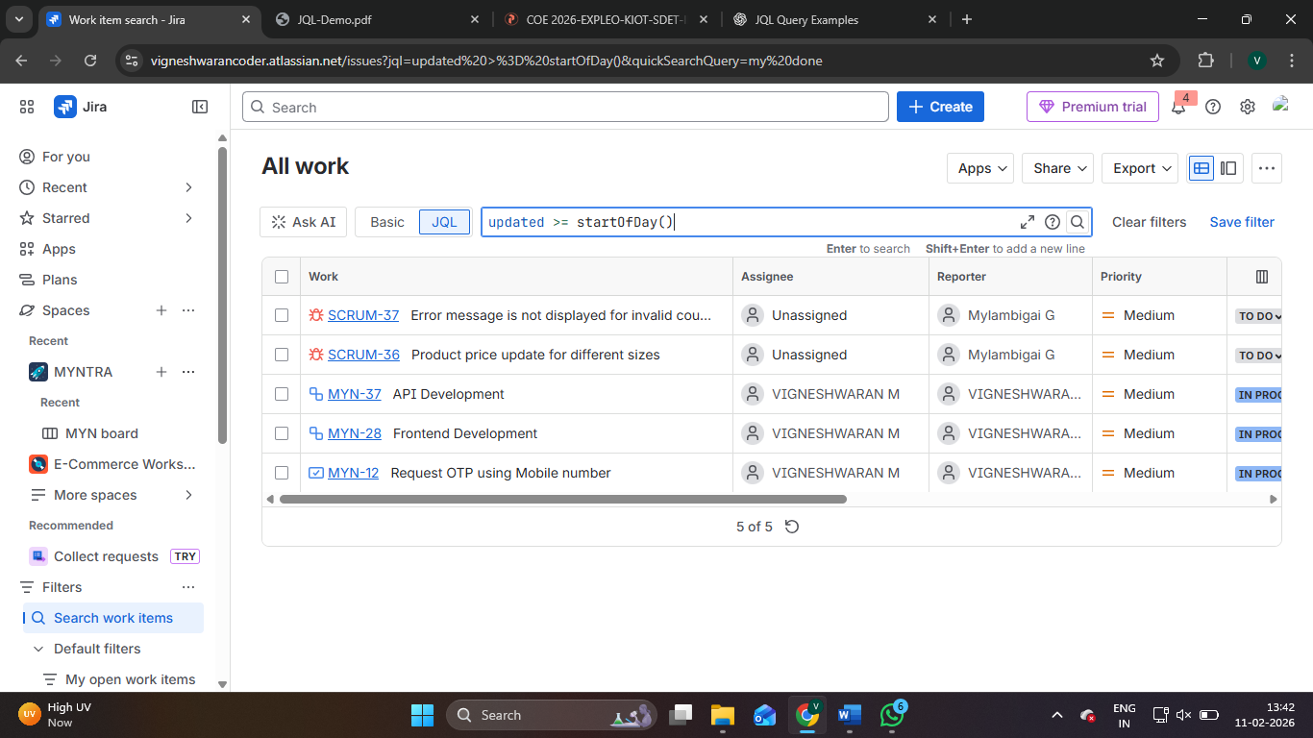

- sprint = 172
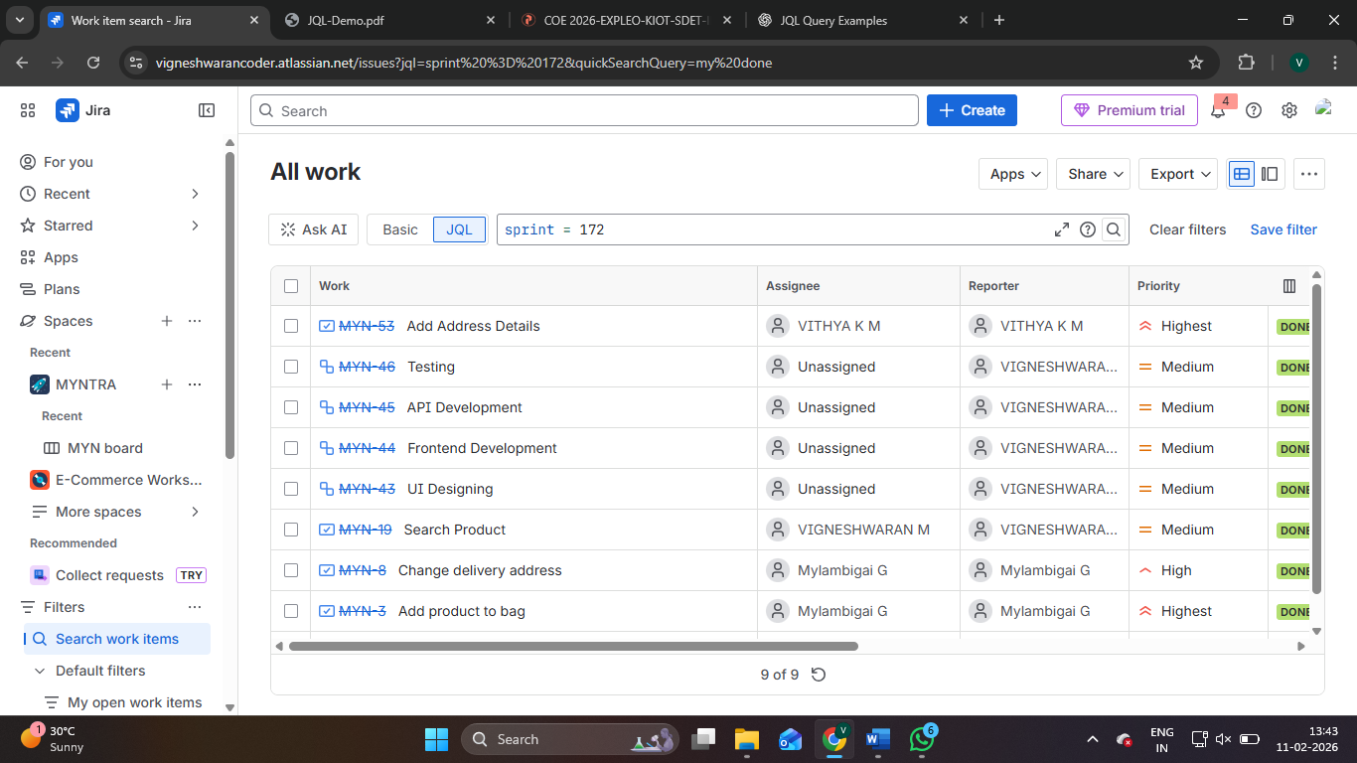

- project = MYNTRA AND issuetype IN (Story, Bug) AND sprint in openSprints() AND status != Done ORDER BY priority DESC, created ASC
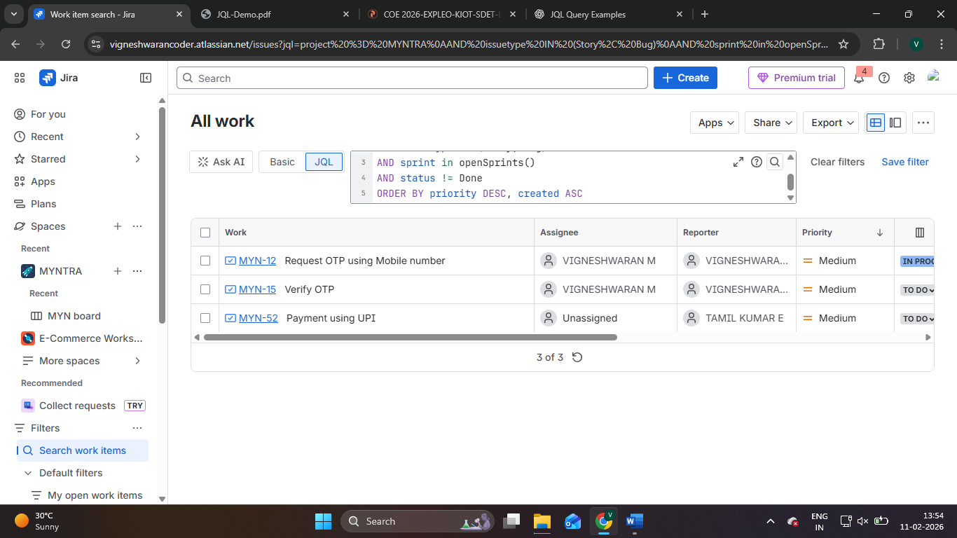

- project = MYN AND created >= -1d
